WEEK 5
MODULE 9

Problem 2:
Given ERD:
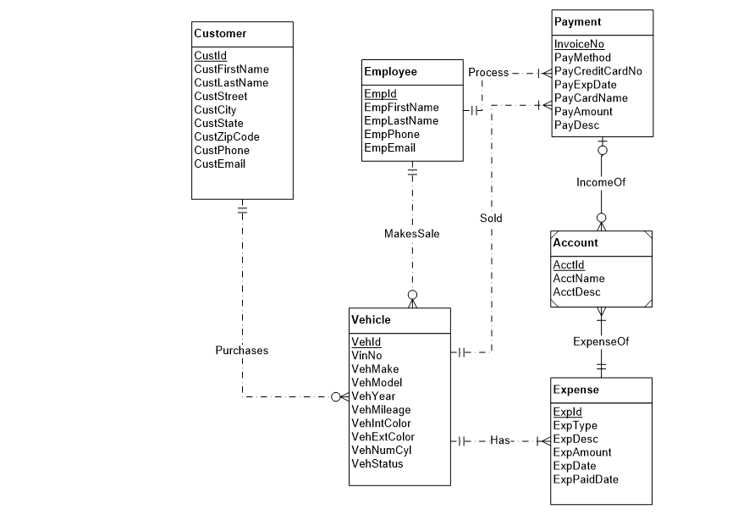

Error List:
- ‘Sold’ is a redundent relation. It can be derived from others.
- ‘Process’ relation has wrong cardinality. An employee can process no payment.
- ‘IncomeOf’ relation has wrong cardinality. One payment can’t be made from more than one accounts.
- ‘ExpenseOf’ relation has wrong cardinality. One Account may not bear an Expense.
- ‘Account’ is not a weak entity.

Corrected ERD:

